

Department of CSE
Summer Semester – 2026 - 2027

10211CS227 – PROBLEM SOLVING AND TESTING

Faculty Section: S9-2L2L12
Project Title: Smart Parking Management System
Semester: 5

S.No | Name of the Student | VTU No
1 | P.THARUN REDDY | VTU28954

Course code: 10211CS227 Semester: Summer 25-26
Course Name: PROBLEM SOLVING AND TESTING
Slot: S9-2L2L12
Project Title: Smart Parking Management System

Faculty Name: Dr.SUCHITRA. S

TABLE OF CONTENTS

S.No. | Contents | Page No.
1. | Use-case | 3
2. | Problem Statement | 4
3. | Code | 5
4. | Output Screenshot | 8
5. | Result | 9

Faculty Signature

1. CASE STUDY
<< Describe the proposed system/application and its purpose.>>
Smart Parking Management System
The Smart Parking Management System is a console-based application designed to efficiently manage vehicle parking operations in a multi-level parking area.
The main objective of the system is to automate parking-slot allocation, vehicle entry and exit, parking-fee calculation, priority parking, and parking analytics.
It demonstrates key concepts such as:
• Dynamic parking-slot allocation
• Vehicle entry and exit management
• Multi-level parking management
• Parking-fee calculation
• Priority queues for VIP and emergency vehicles
• Parking availability tracking and analytics
The system automatically assigns the nearest available parking slot and stores vehicle details. When a vehicle exits, the parking duration is calculated and the corresponding parking fee is generated.
2. Problem Statement
<< Clearly state the problem that the application aims to solve.>>
The Smart Parking Management System is a console-based application that solves the problem of efficiently managing vehicles in a multi-level parking facility. It reduces manual work by dynamically allocating slots, recording vehicle information, managing entry and exit, calculating fees, and generating reports.
Functional Requirements
1. Vehicle Entry Management
• Allocate the nearest available parking slot.
• Store vehicle details such as vehicle number and vehicle type.
• Automatically assign the appropriate parking level.
2. Vehicle Exit Management
• Remove the vehicle from its assigned parking slot.
• Calculate the total parking duration.
• Generate the parking fee based on parking duration.
3. Parking Analytics
• Find the most occupied parking level.
• Detect peak parking hours.
• Track parking availability.
• Generate parking reports.
4. Priority Parking
• Handle VIP vehicles.
• Handle emergency vehicles.
• Use priority queues to process priority vehicles efficiently.
3. Code
<< Provide the complete source code.>>
from datetime import datetime
import heapq

LEVELS = 3
SLOTS_PER_LEVEL = 5
FEE_PER_HOUR = 50

class SmartParking:
def __init__(self):
self.slots = {
level: [None] * SLOTS_PER_LEVEL
for level in range(1, LEVELS + 1)
}
self.vehicles = {}
self.priority_queue = []

def find_nearest_slot(self):
for level in range(1, LEVELS + 1):
for slot in range(SLOTS_PER_LEVEL):
if self.slots[level][slot] is None:
return level, slot + 1
A return None

def park_vehicle(self, vehicle_no, vehicle_type):
if vehicle_no in self.vehicles:
print("Vehicle is already parked.")
return

position = self.find_nearest_slot()
if position is None:
print("Parking is full.")
return

level, slot = position
entry_time = datetime.now()

self.slots[level][slot - 1] = vehicle_no
self.vehicles[vehicle_no] = {
"level": level, "slot": slot,
"type": vehicle_type, "entry": entry_time
}

priority = 1 if vehicle_type == "Emergency" else 2 if vehicle_type == "VIP" else 3
heapq.heappush(self.priority_queue, (priority, vehicle_no))

print("\nVehicle parked successfully.")
print("Vehicle:", vehicle_no)
print("Level:", level)
print("Slot:", slot)

def exit_vehicle(self, vehicle_no):
if vehicle_no not in self.vehicles:
print("Vehicle not found.")
return

vehicle = self.vehicles[vehicle_no]
duration = datetime.now() - vehicle["entry"]
hours = max(1, int(duration.total_seconds() // 3600))
fee = hours * FEE_PER_HOUR

self.slots[vehicle["level"]][vehicle["slot"] - 1] = None
del self.vehicles[vehicle_no]

print("\n--- Vehicle Exit ---")
print("Vehicle:", vehicle_no)
print("Parking Duration:", hours, "hour(s)")
print("Parking Fee: Rs.", fee)
print("Vehicle exited successfully.")

def display_status(self):
print("\n--- Parking Availability ---")
for level in range(1, LEVELS + 1):
occupied = sum(x is not None for x in self.slots[level])
print(f"Level {level}: {occupied} occupied, {SLOTS_PER_LEVEL - occupied} available")

def analytics(self):
occupied = {
level: sum(x is not None for x in self.slots[level])
for level in range(1, LEVELS + 1)
}
most_occupied = max(occupied, key=occupied.get)

print("\n--- Parking Analytics ---")
print("Most Occupied Level:", most_occupied)
print("Occupied Slots:", occupied[most_occupied])

def priority_vehicles(self):
print("\n--- Priority Vehicles ---")
found = False

for priority, vehicle_no in sorted(self.priority_queue):
if vehicle_no in self.vehicles:
print(vehicle_no, "-", self.vehicles[vehicle_no]["type"])
found = True

if not found:
print("No priority vehicles currently parked.")

def report(self):
print("\n--- Parking Report ---")
if not self.vehicles:
print("No vehicles currently parked.")
return

for vehicle_no, details in self.vehicles.items():
print(vehicle_no, "| Level:", details["level"],
"| Slot:", details["slot"],
"| Type:", details["type"])

def main():
parking = SmartParking()

while True:
print("\n===== SMART PARKING MANAGEMENT =====")
print("1. Vehicle Entry")
print("2. Vehicle Exit")
print("3. Parking Availability")
print("4. Parking Analytics")
print("5. Priority Vehicles")
print("6. Parking Report")
print("7. Exit")

choice = input("Enter your choice: ")

if choice == "1":
vehicle_no = input("Enter vehicle number: ").upper()
vehicle_type = input("Enter type (Normal/VIP/Emergency): ").title()
parking.park_vehicle(vehicle_no, vehicle_type)
elif choice == "2":
vehicle_no = input("Enter vehicle number: ").upper()
parking.exit_vehicle(vehicle_no)
elif choice == "3":
parking.display_status()
elif choice == "4":
parking.analytics()
elif choice == "5":
parking.priority_vehicles()
elif choice == "6":
parking.report()
elif choice == "7":
print("Thank you!")
break
else:
print("Invalid choice.")

if __name__ == "__main__":
main()
4. OUTPUT SCREENSHOT
Sample console output:
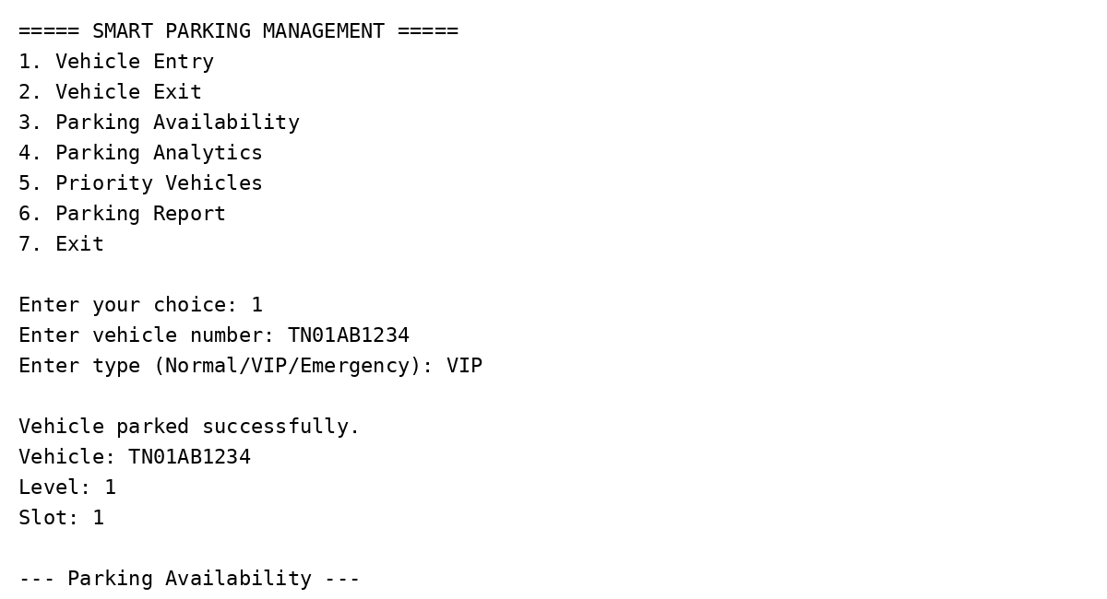
5. Result
<< State briefly whether the intended objective was achieved.>>
The Smart Parking Management System was successfully designed and implemented as a console-based application. The system dynamically allocates parking slots, manages vehicle entry and exit, calculates parking fees, handles VIP and emergency vehicles using priority queues, and provides parking availability, analytics, and reports.

